**EXPERIMENT-10**

**NAME:** SHAIKH MUBASHIRA TUFEL AHMED

**ROLL NO:** 612055  **COURSE:** ADVANCE DEVOPS(ITL504)

**BRANCH:** T.E. INFORMATION TECHNOLOGY (SEM 5)

1. **What is Nagios? Comment on why we need Nagios tool?**

🡪Nagios is an open-source tool that is widely used to monitor the systems, infrastructure, and networks so that performance bottlenecks can be identified. The tool offers several services like monitoring of servers, applications, and switches and also sends alerts to the user when any performance issue is identified in the system. The tool is also capable to send alerts when the issue is identified.

**Need of Nagios:**

* Nagios can describe the event handler that executes at the time of host events or services to take a resolution for proactive problems. It is also used to support redundancy in monitoring hosts.
* It can also be monitored in hardware tools like a probe for alarm, a temperature that can send collected information through the network by configured written plugins. The remote monitoring can be established through Nagios remote plugin executor via SSL and SSH encrypted channels. The automated rotation of log files and parallel execution of service checks can be made using Nagios.
* Nagios performs the process on the database backend, data graphing and implements redundancy in monitoring the host. The web interface to view the current status of the network, problem history, notification manager, files, logs, etc
* Nagios has other services like Nagios Remote Plugin Executor abbreviated as NRPE, Nagios Remote Data processor (NRDP), Nagios Cross-Platform Agent, and for windows client machines it uses NSClient++.

**Step 1: AWS Management Console Dashboard.** 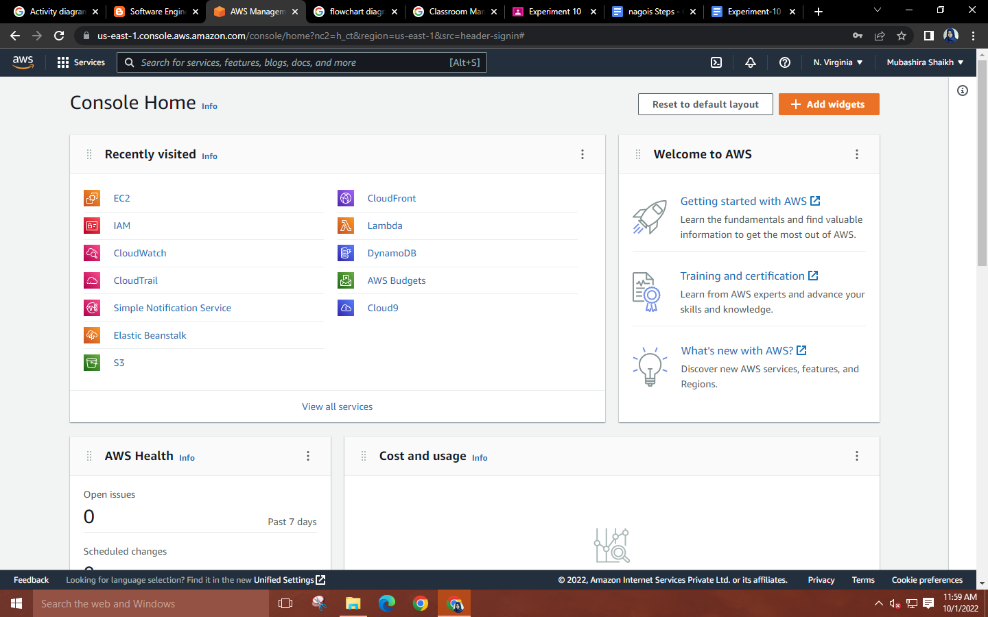

**Step 2: Search for EC2🡪 Click on Launch instance🡪 Give a name to your instance and create an Amazon Linux instance with 2AMI version.** 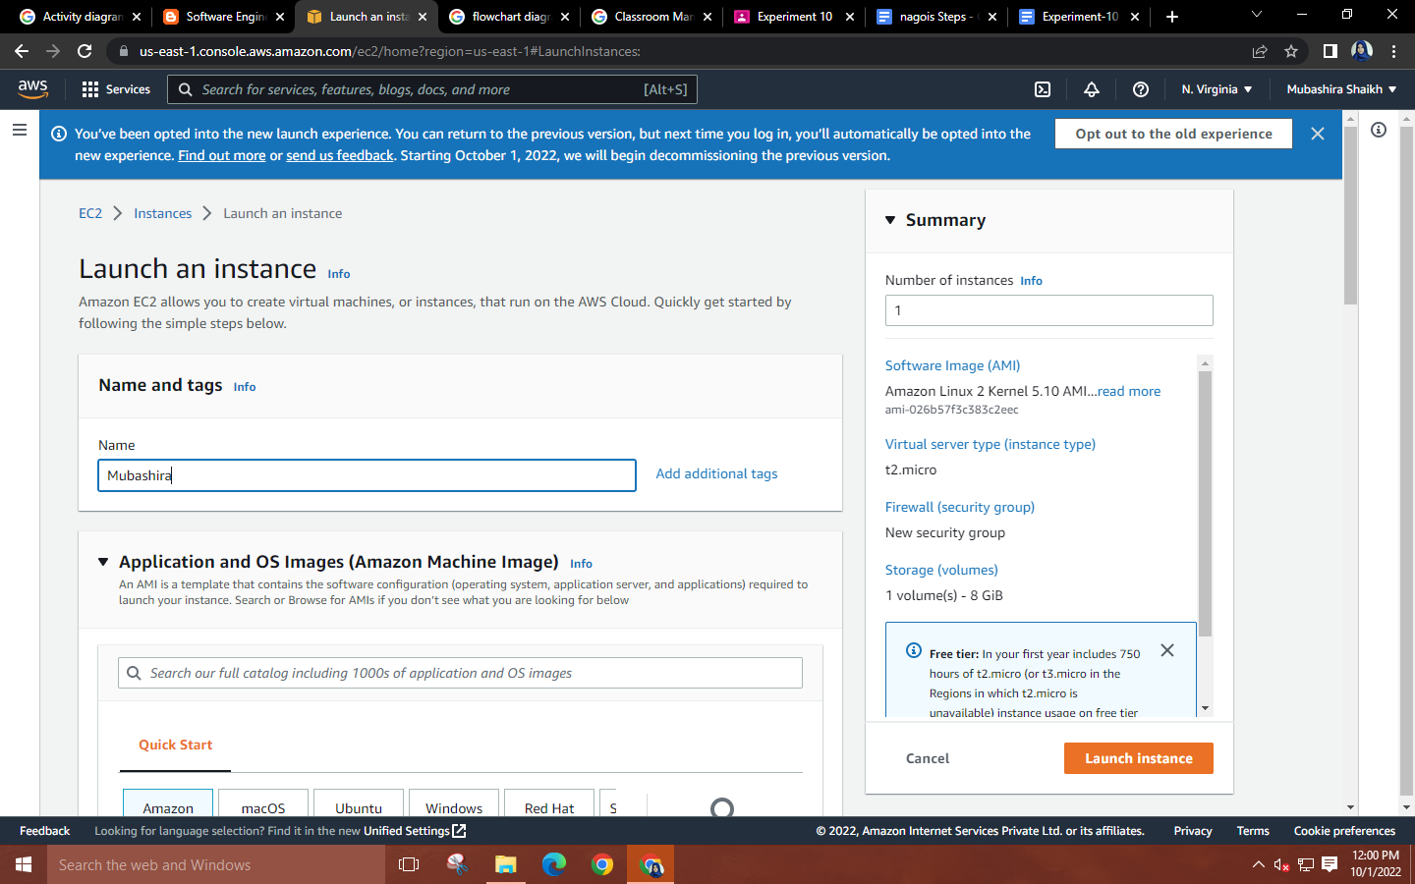 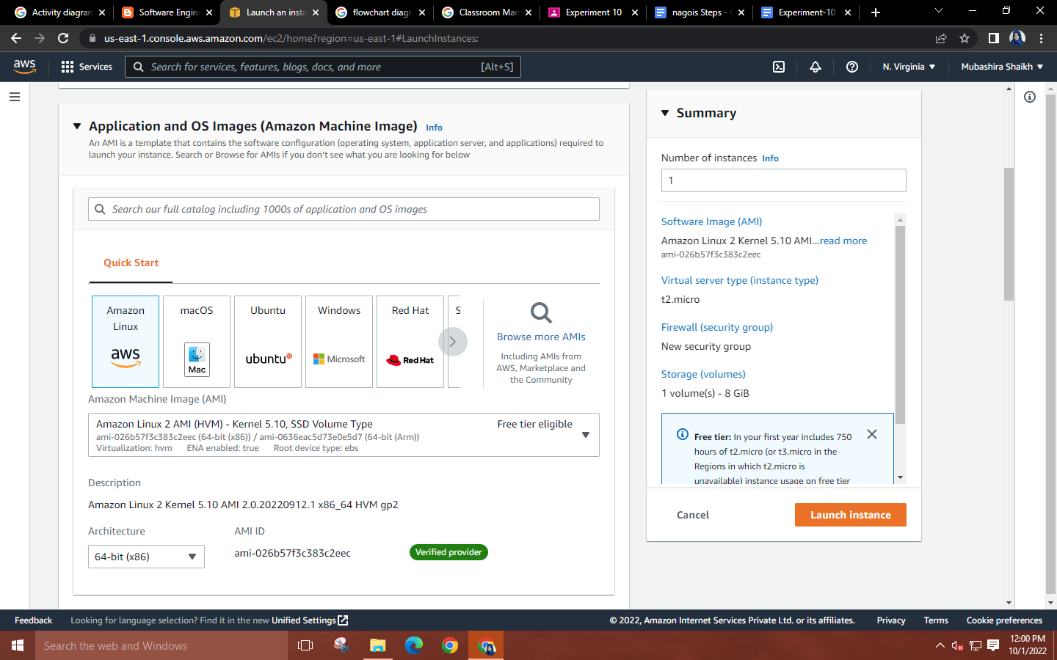

**Step 3: Create new key pair for your instance.**

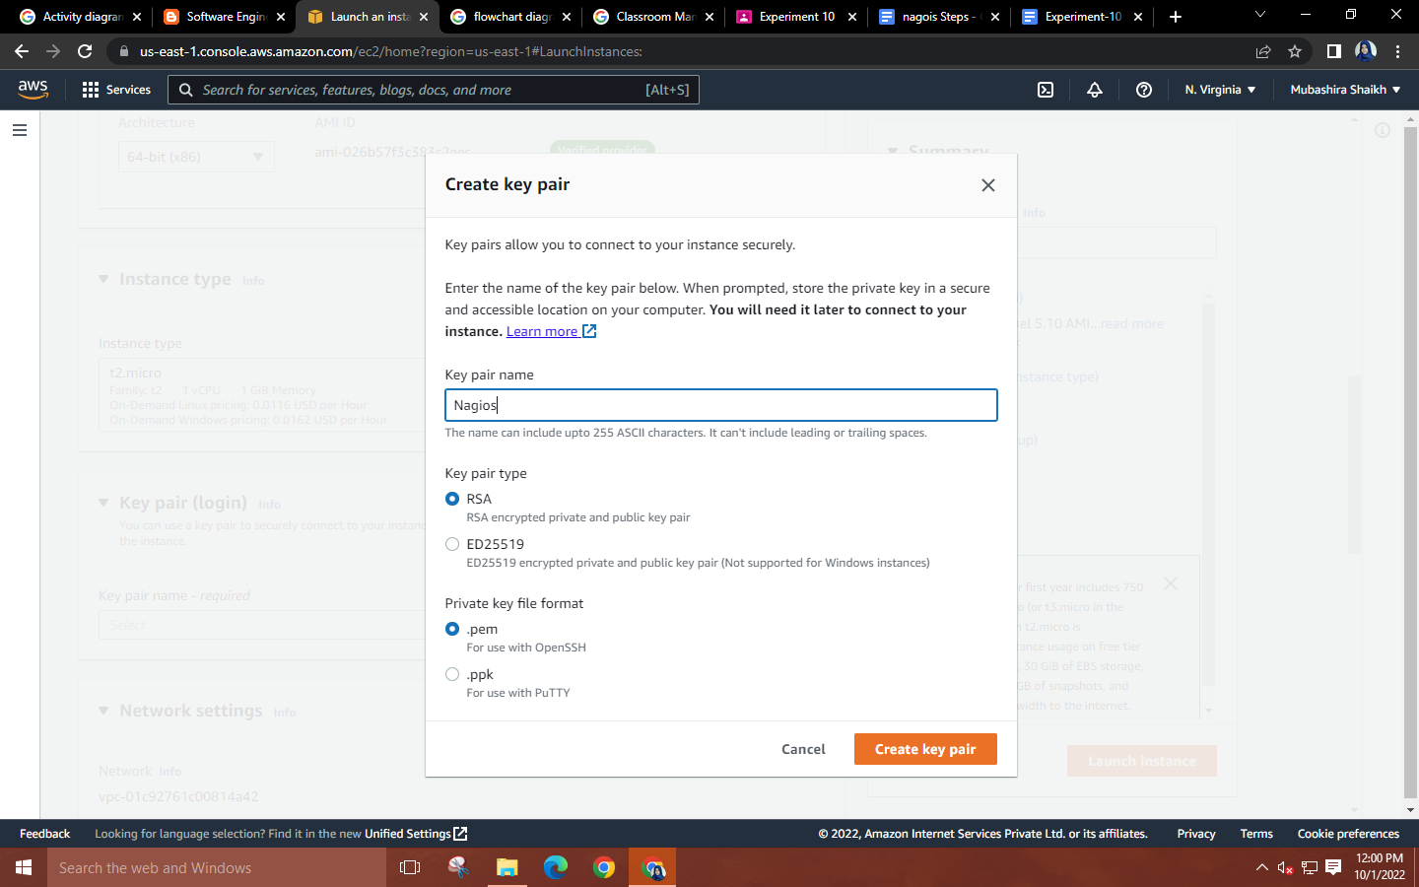

**Step 4: Network Settings🡪allow the HTTPS and HTTP traffic🡪Click on edit.**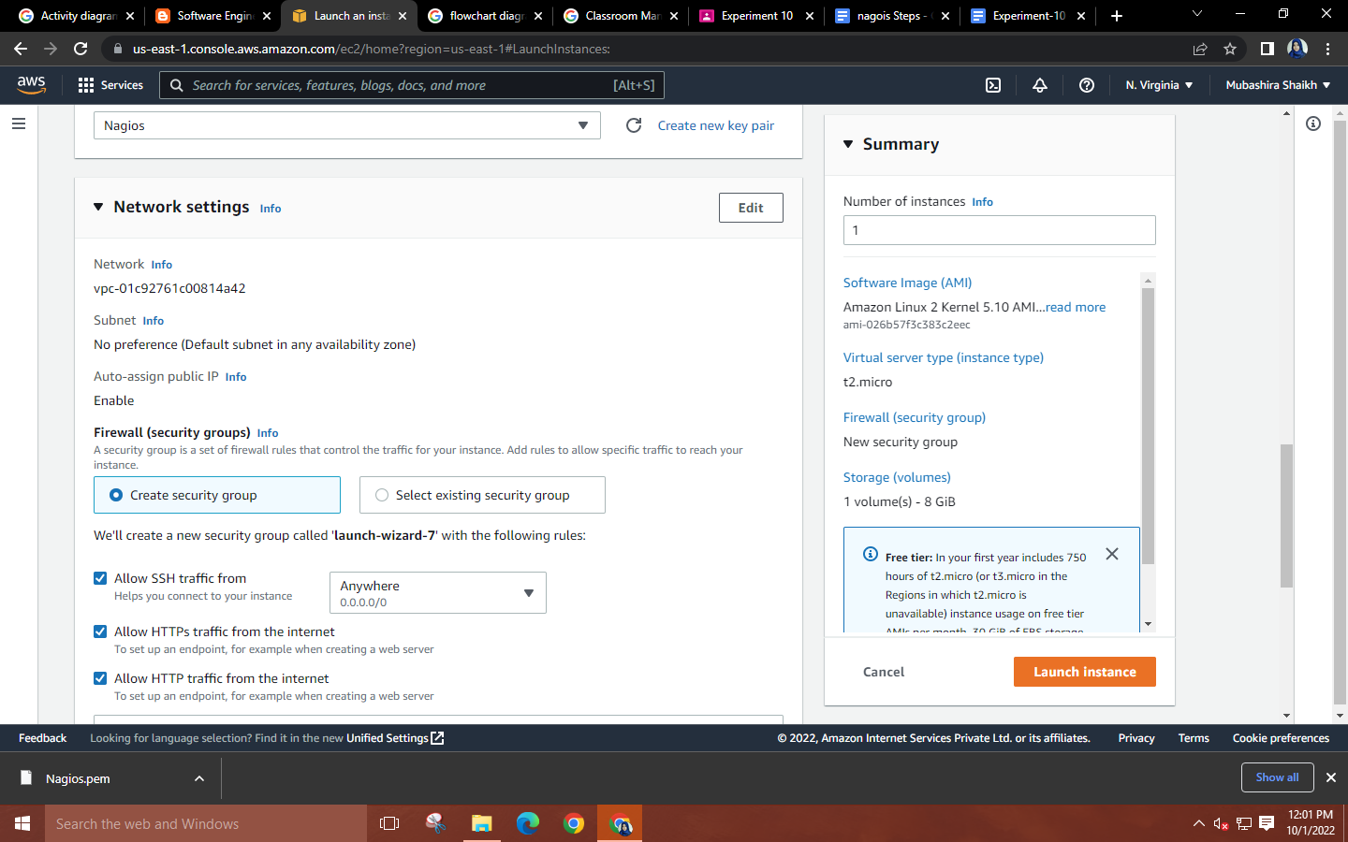

**Step 5: Click on “Add security group rule” 🡪In Type select “All TCP”🡪In source type choose “Anywhere”.**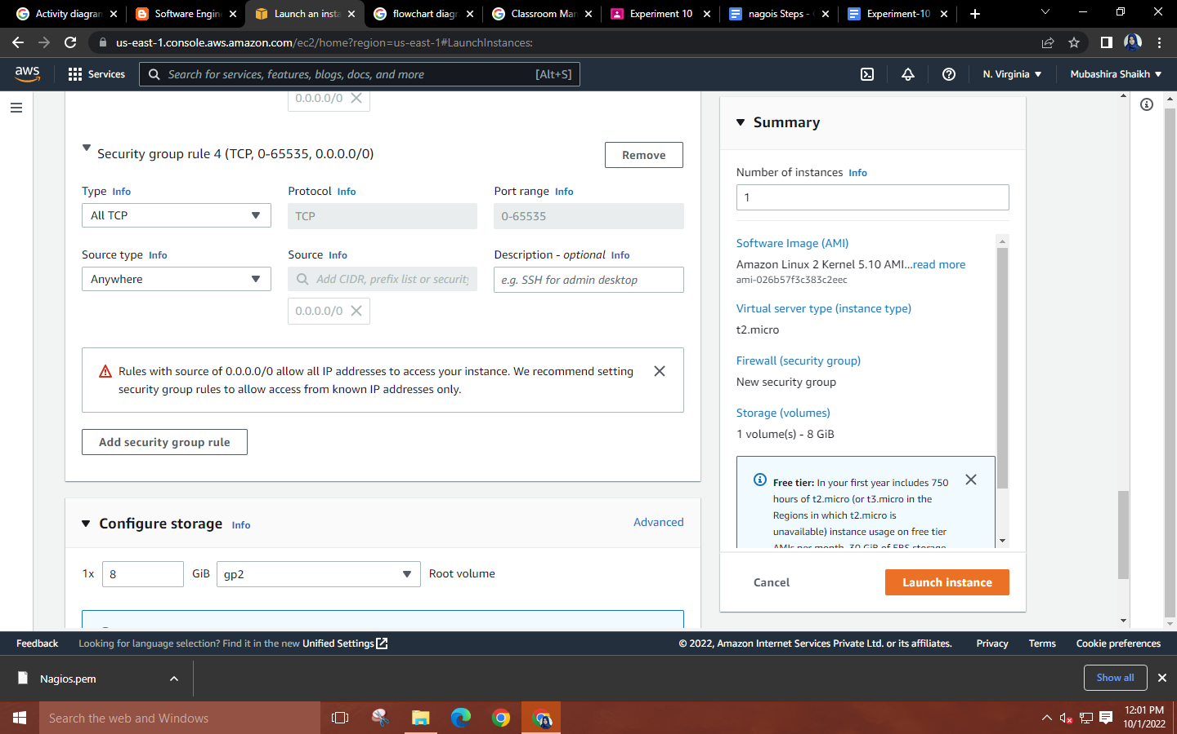

**Step 6: Launch the instance.**

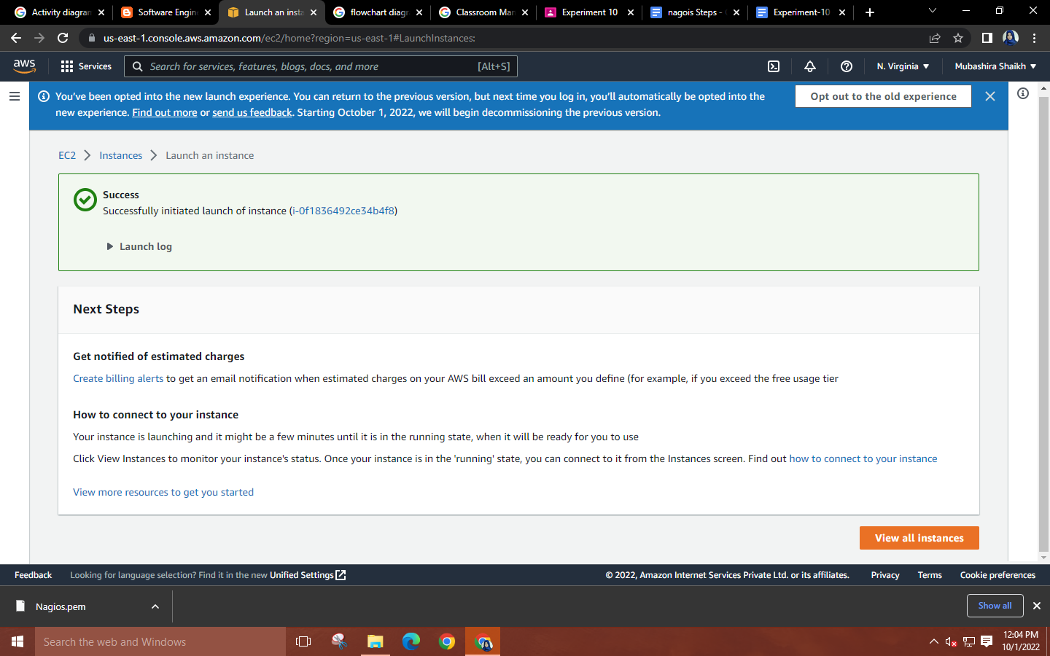

**Step 7: Launch MobaXterm🡪Select SSH session🡪Copy the public DNS of your instance and paste it into the remote host. Use the downloaded key pair as the private key.**  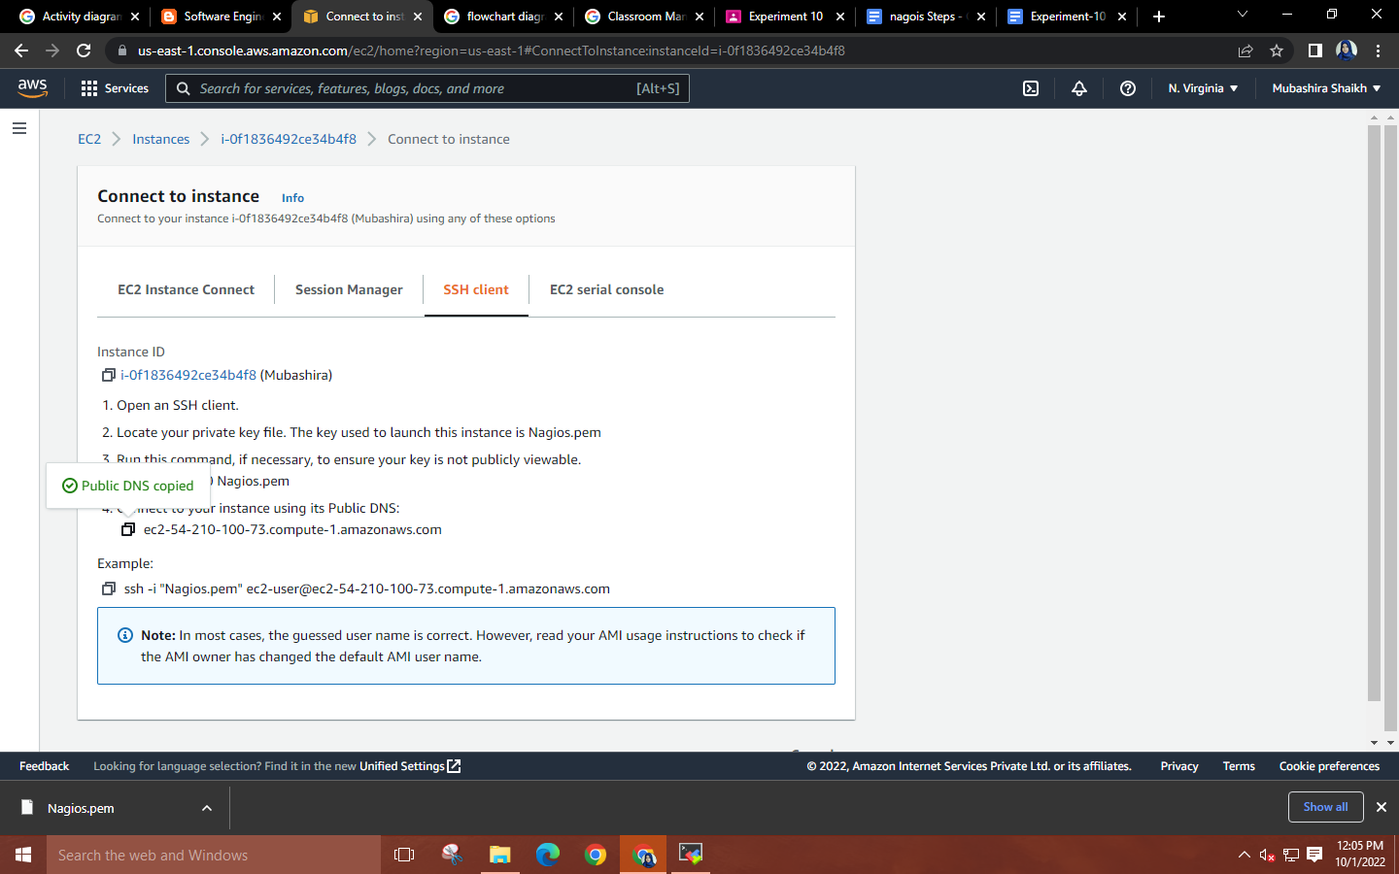

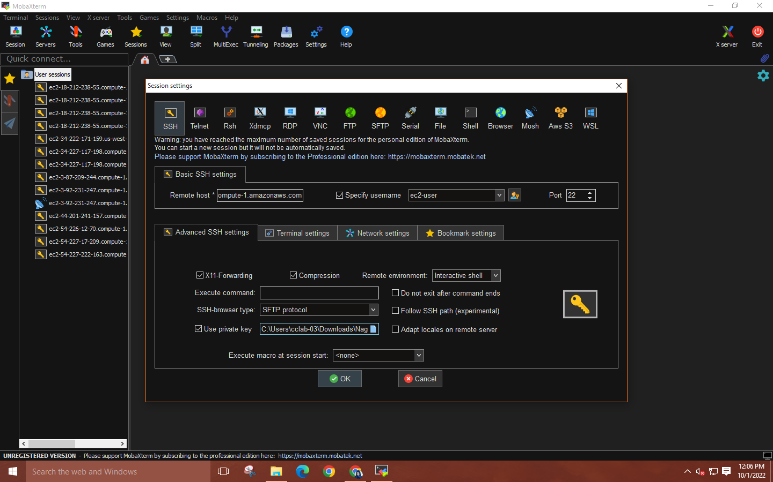

**Step 8: Run the following commands for Nagios installation on EC2 Linux**

* **sudo su**
* **yum install httpd php**
* **yum install gcc glibc glibc-common**
* **yum install gd gd-devel**
* **adduser -m nagios**
* **passwd nagios**
* **groupadd nagioscmd**
* **usermod -a -G nagioscmd nagios**
* **usermod -a -G nagioscmd apache**
* **mkdir ~/downloads**
* **cd ~/downloads**
* **wget http://prdownloads.sourceforge.net/sourceforge/nagios/nagios-4.0.8.tar.gz**
* **wget http://nagios-plugins.org/download/nagios-plugins-2.3.3.tar.gz**
* **tar zxvf nagios-4.0.8.tar.gz**
* **cd nagios-4.0.8**
* **./configure --with-command-group=nagioscmd**
* **make all**
* **make install**
* **make install-init**
* **make install-config**
* **make install-commandmode**
* **make install-webconf**
* **htpasswd -c /usr/local/nagios/etc/htpasswd.users nagiosadmin**
* **service httpd restart**
* **cd ~/downloads**
* **tar zxvf nagios-plugins-2.3.3.tar.gz**
* **cd nagios-plugins-2.3.3**
* **./configure --with-nagios-user=nagios --with-nagios-group=nagios**
* **make**
* **make install**
* **chkconfig --add nagios**
* **chkconfig nagios on**
* **/usr/local/nagios/bin/nagios -v /usr/local/nagios/etc/nagios.cfg**
* **service nagios start**
* **service httpd restart**

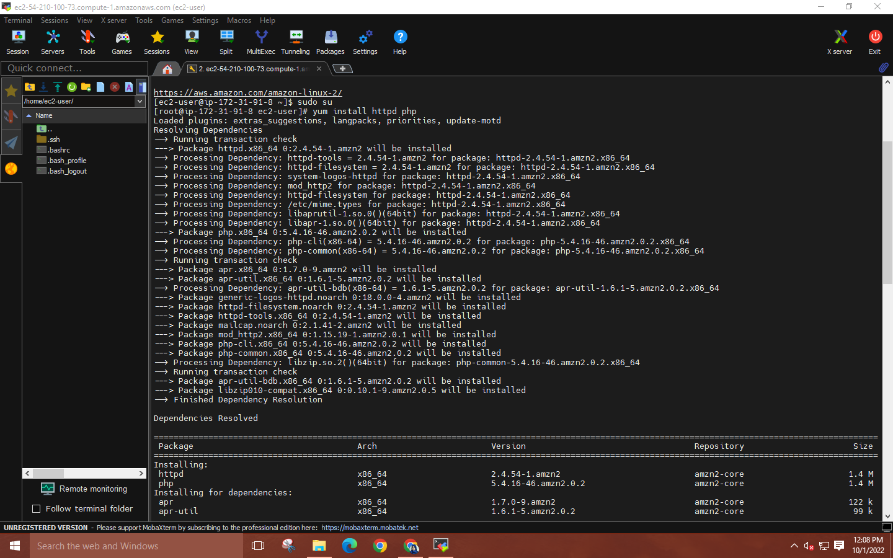

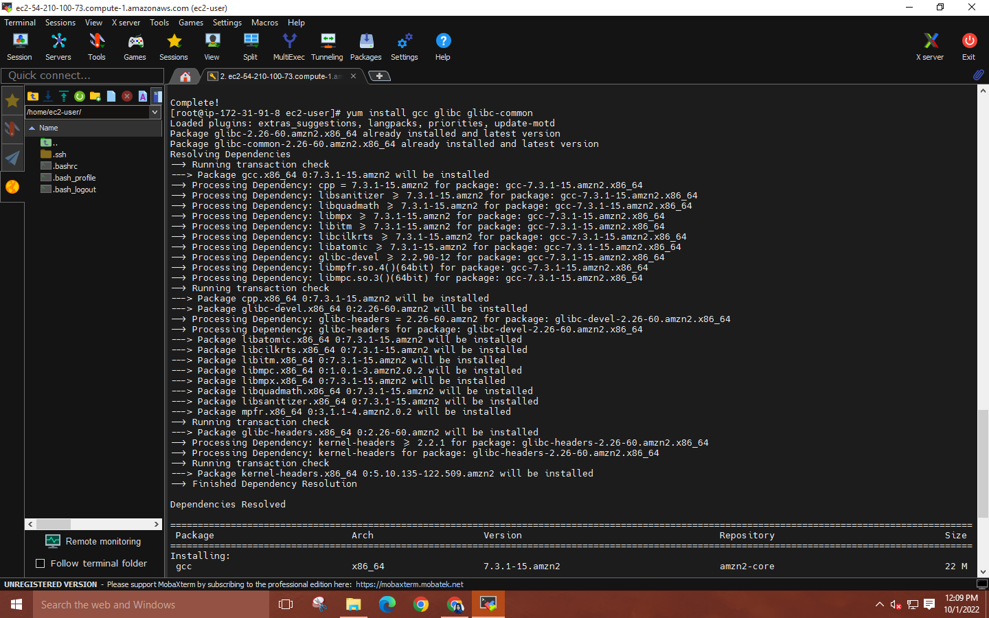

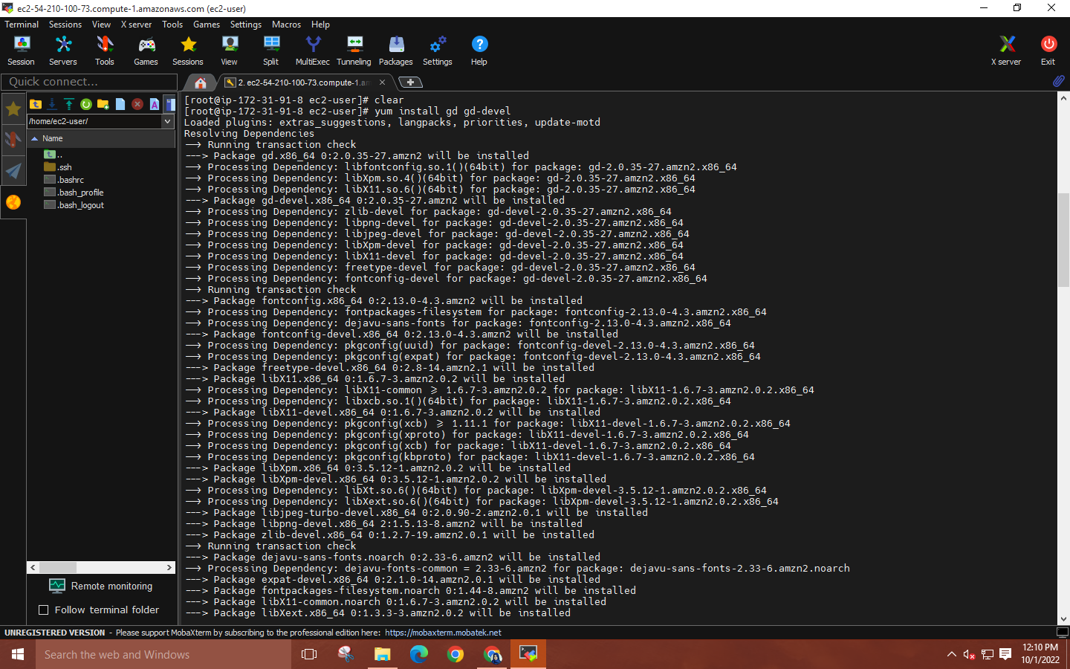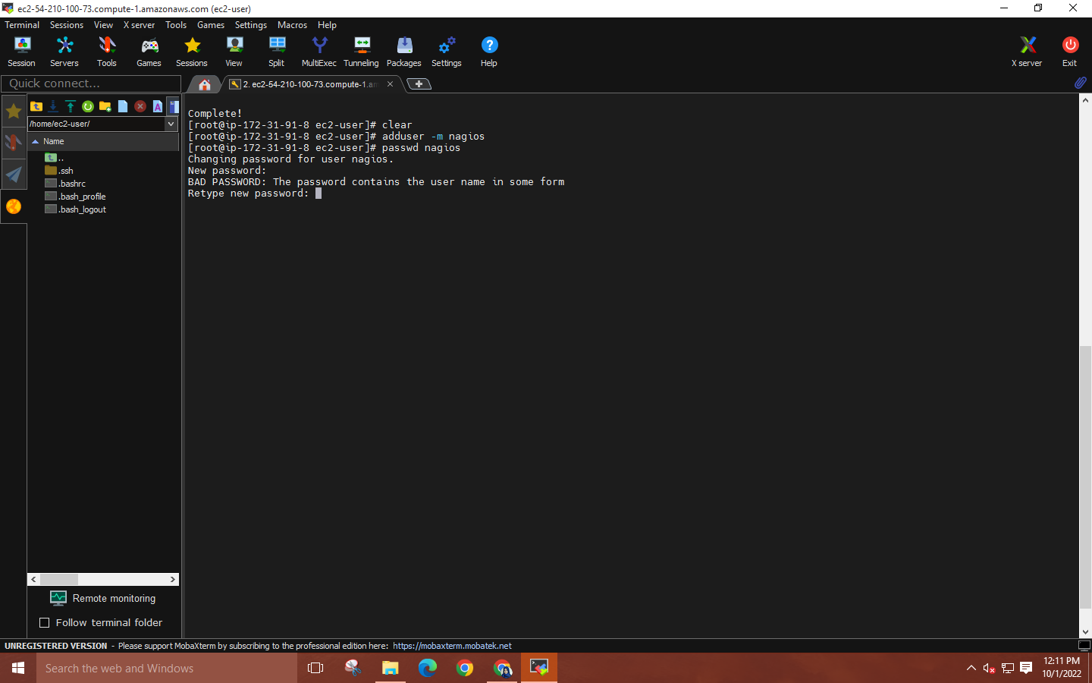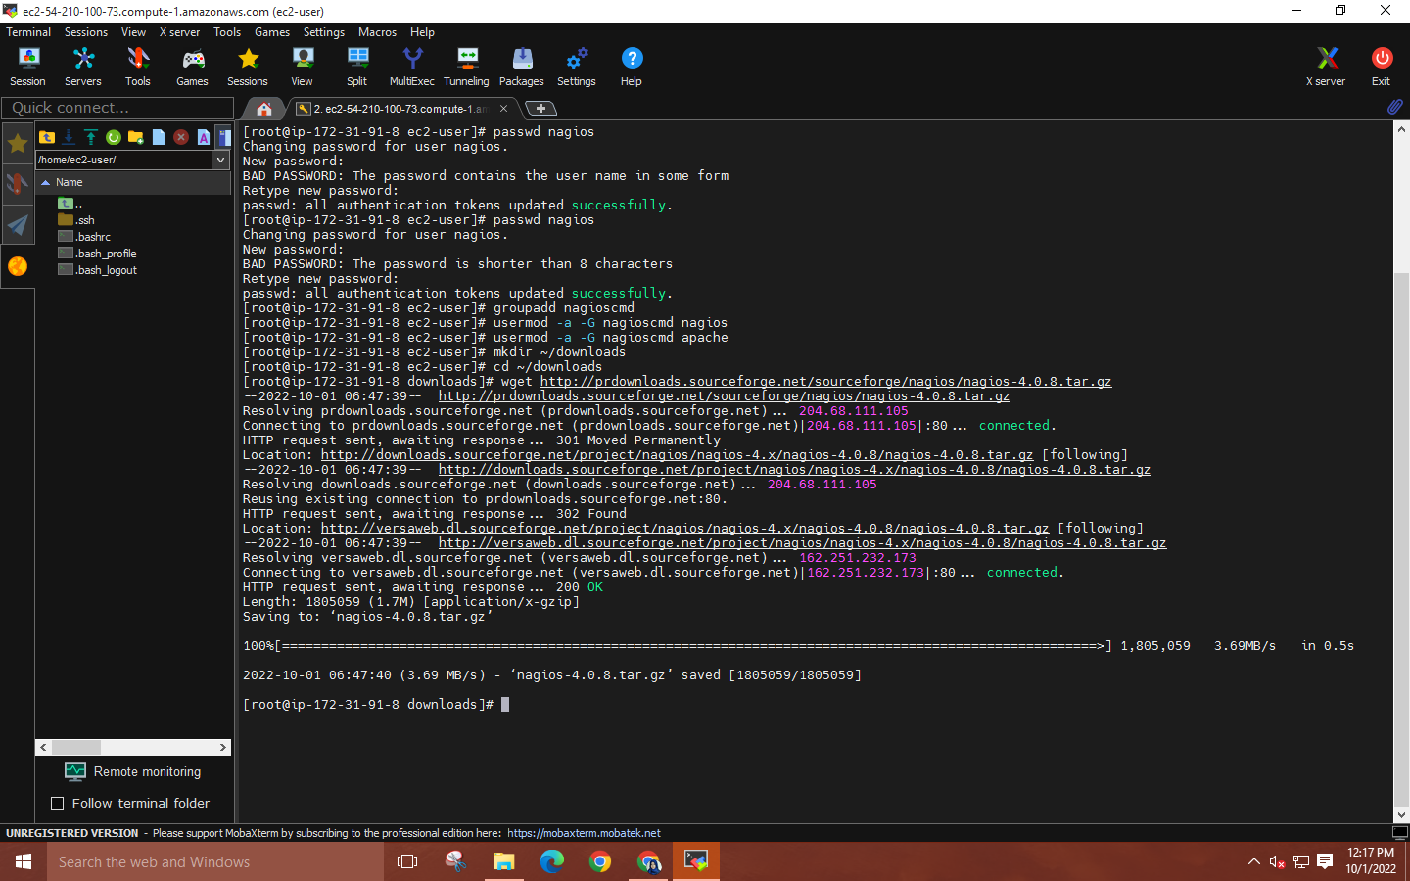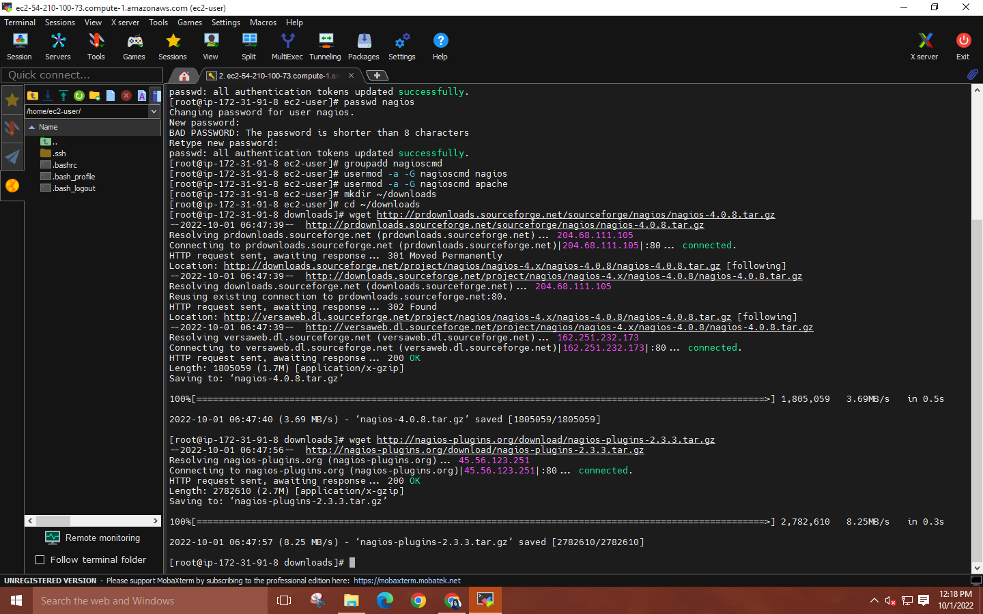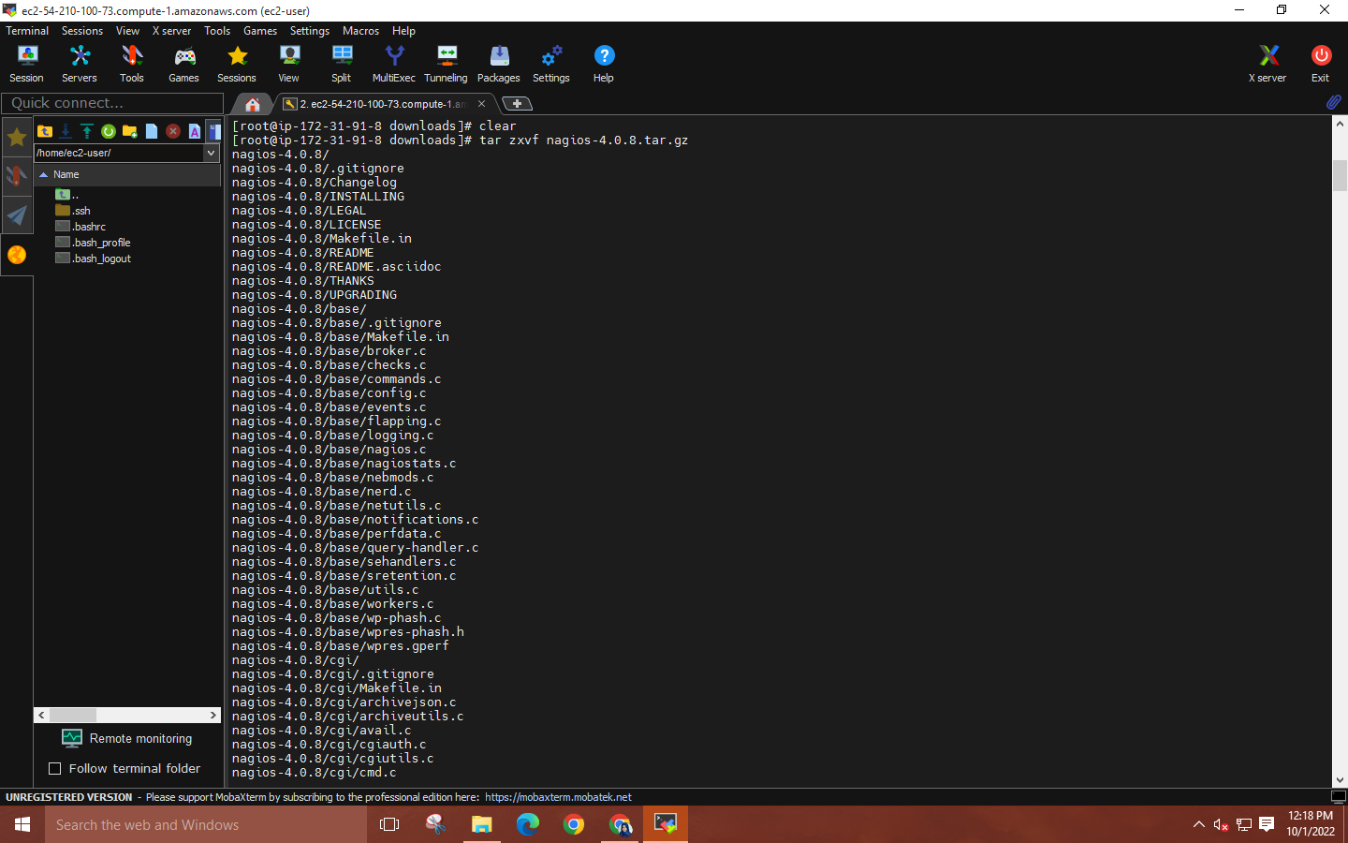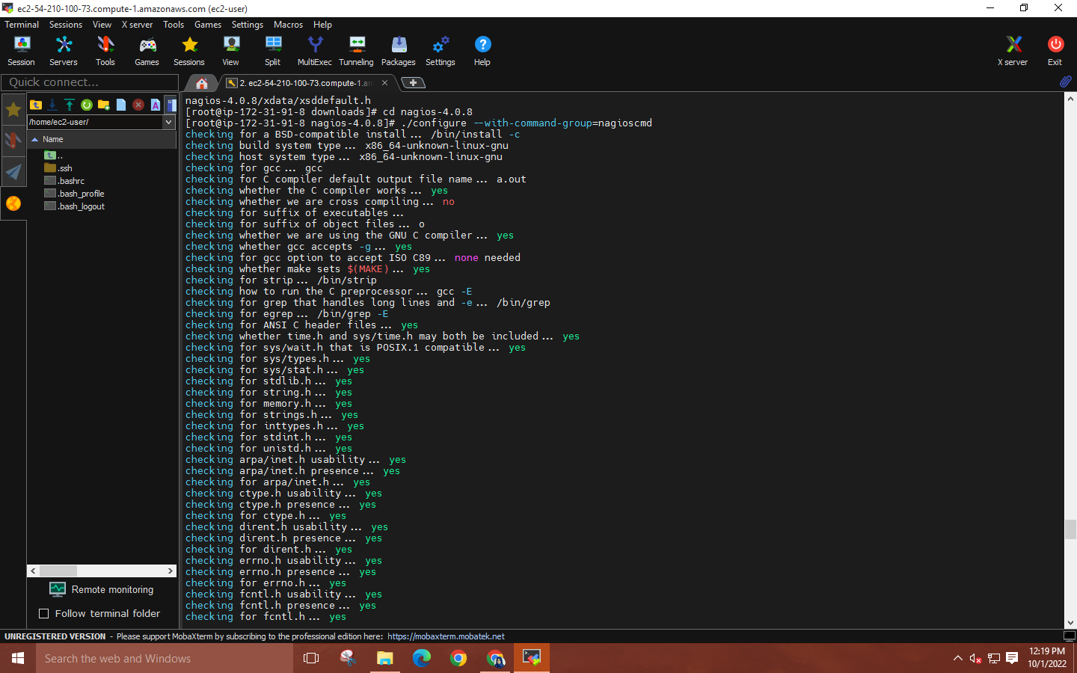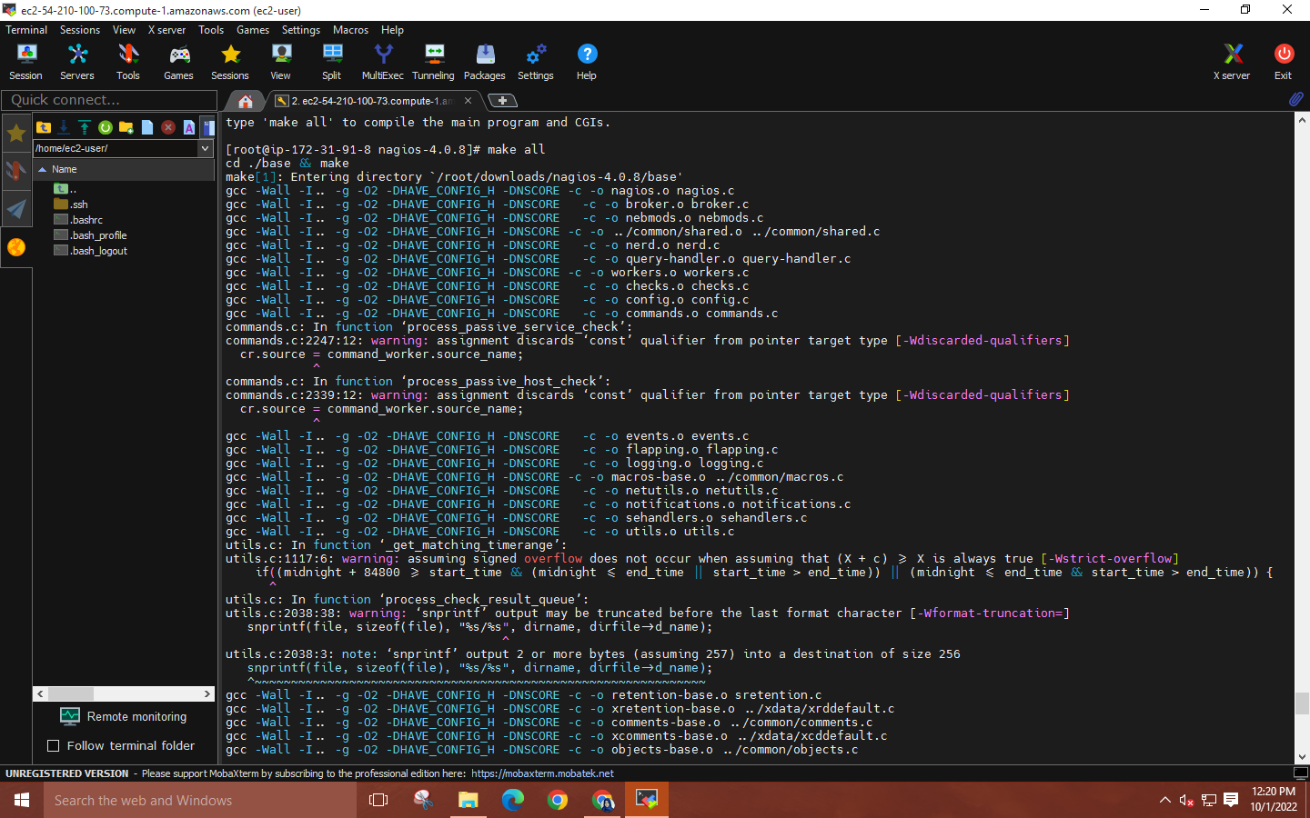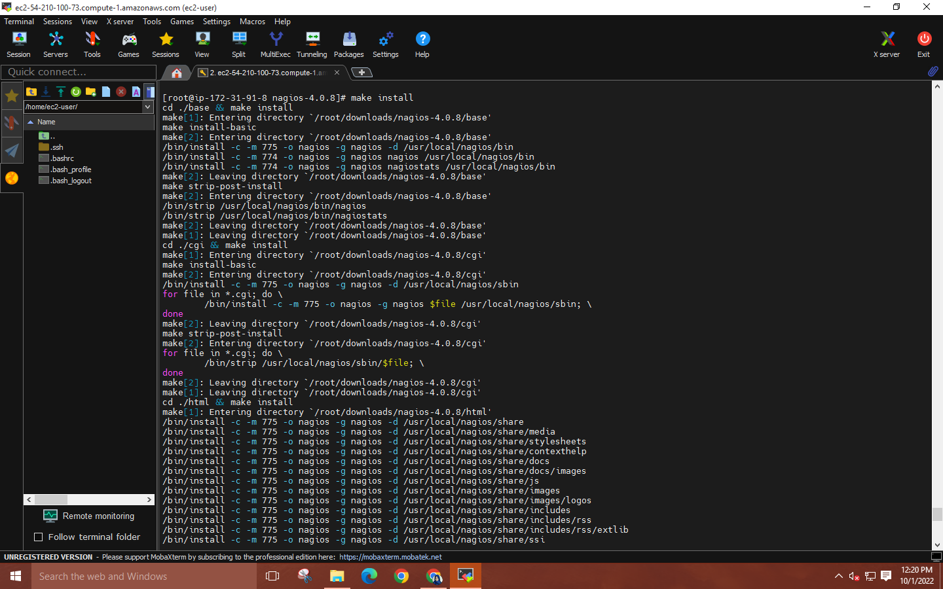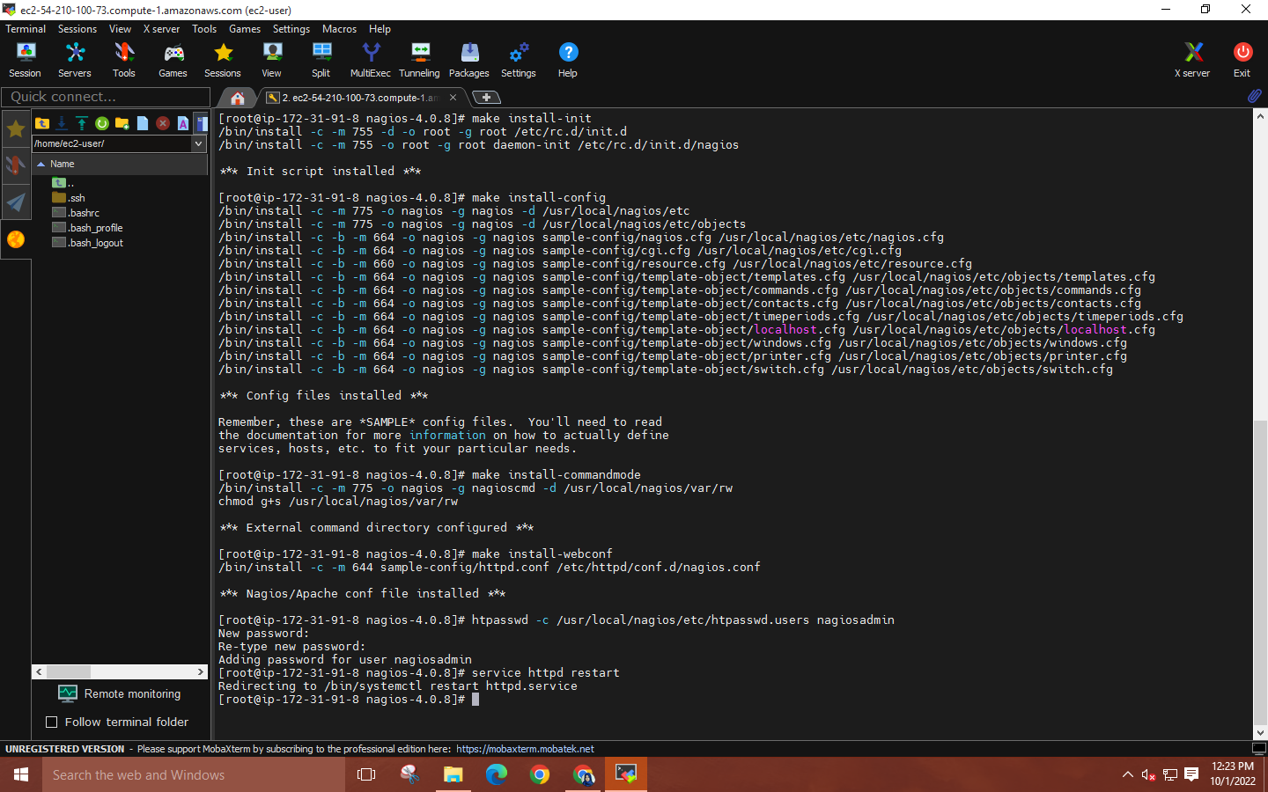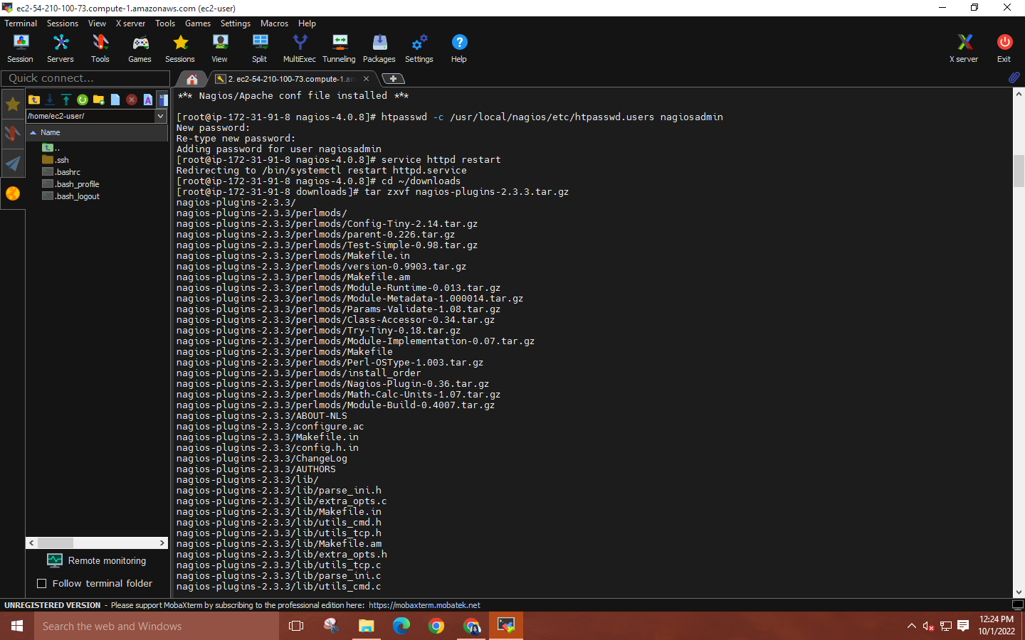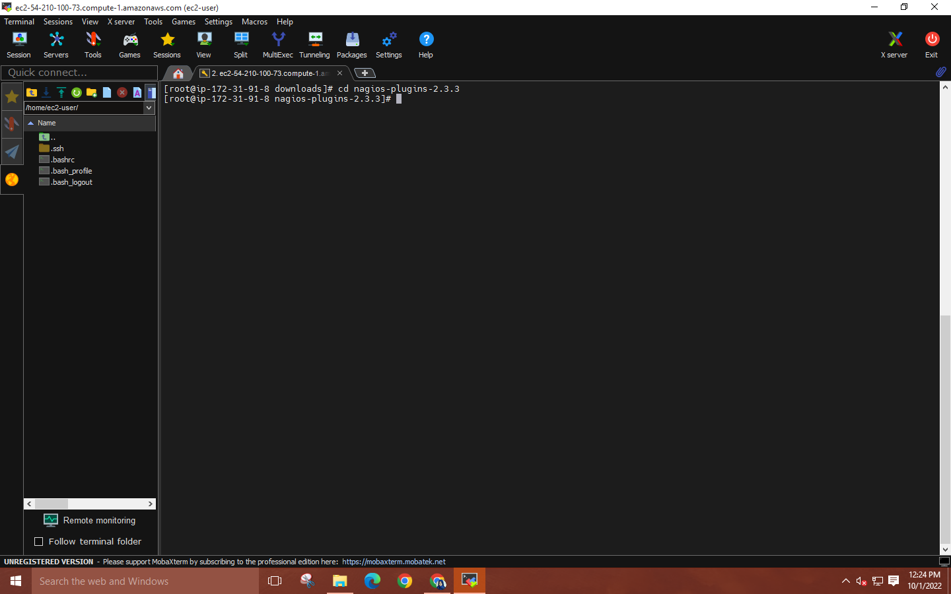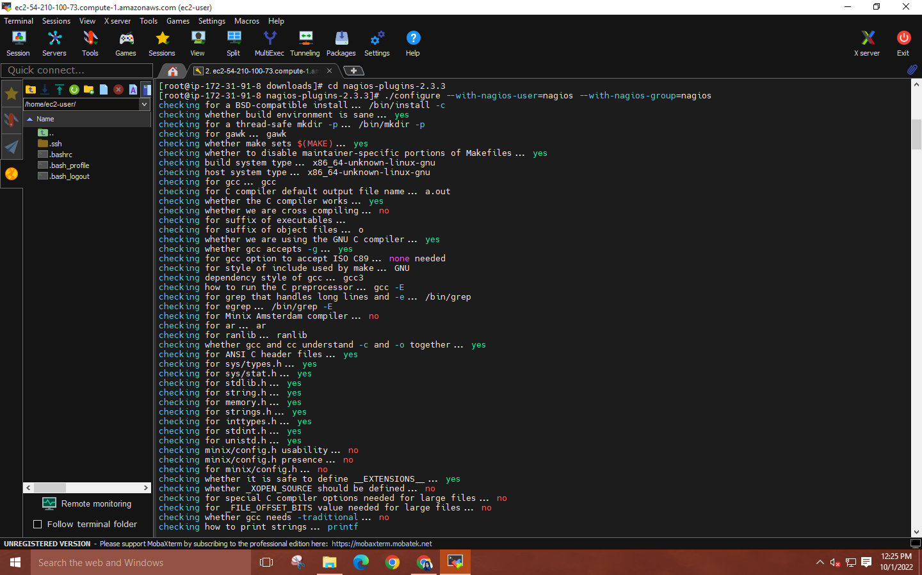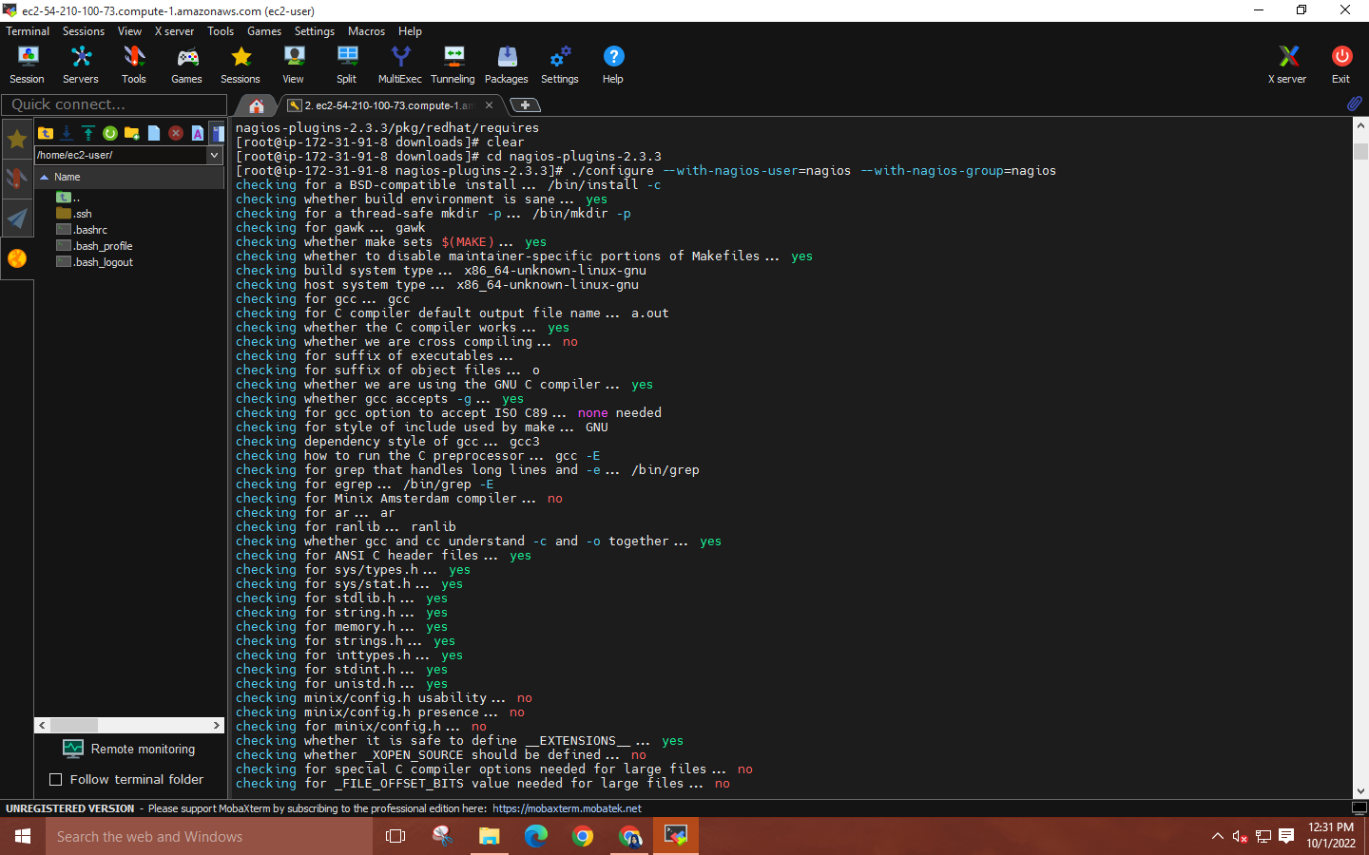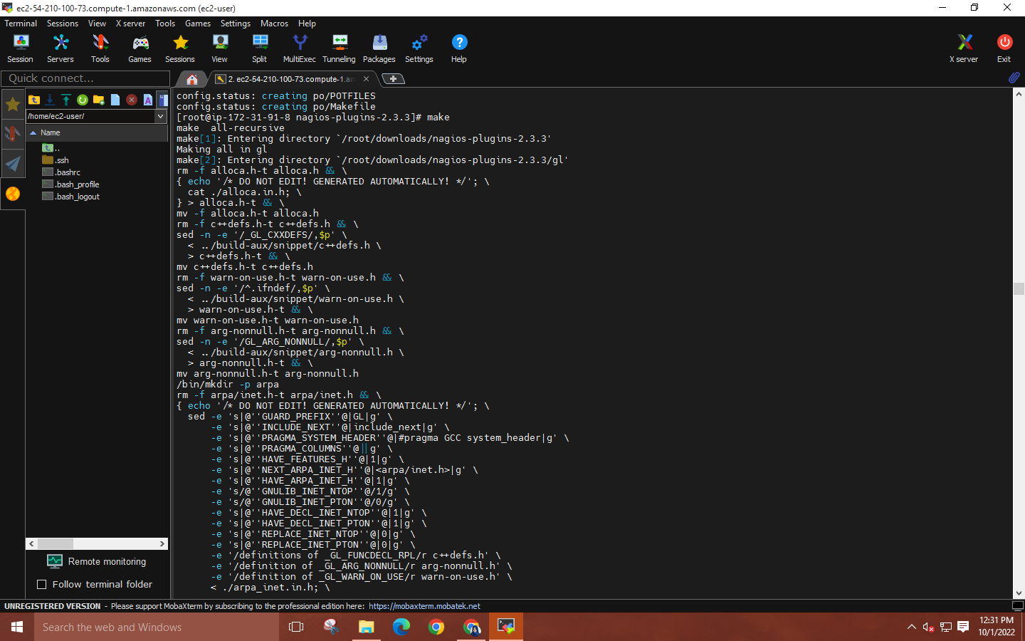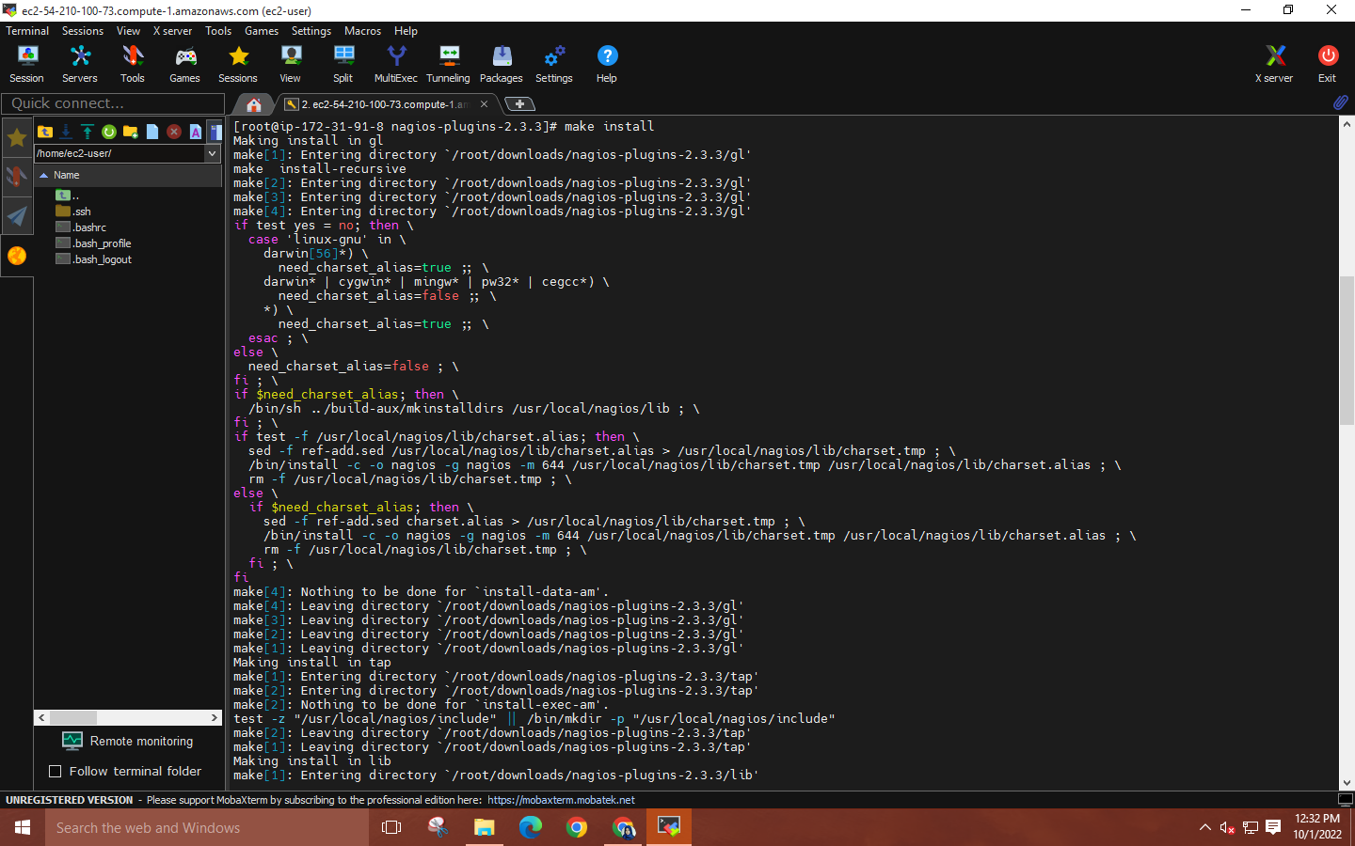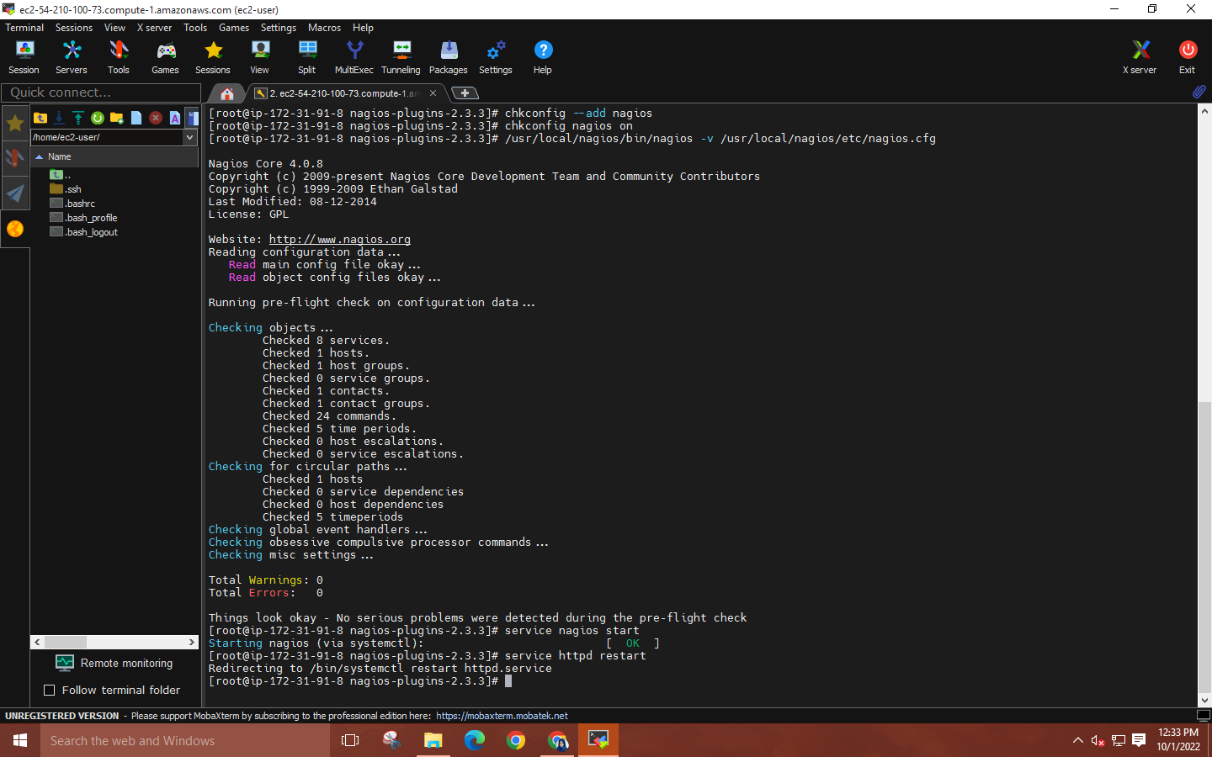

**Step 9: Copy the IPV4 address from the EC2 instance details and paste it into a web browser by adding “/nagios.**

**Sign in by using**

**Username🡪 “nagiosadmin”**

**Password🡪 “nagios”**

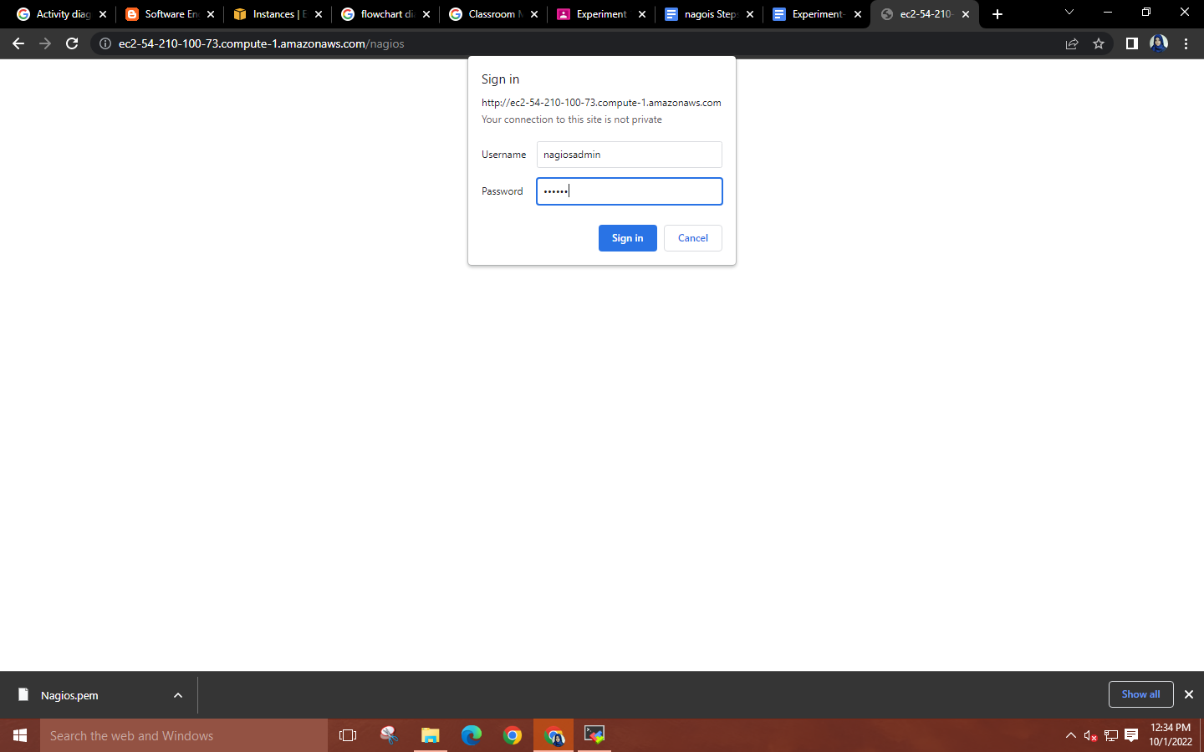

**Nagios Dashboard will be displayed.**

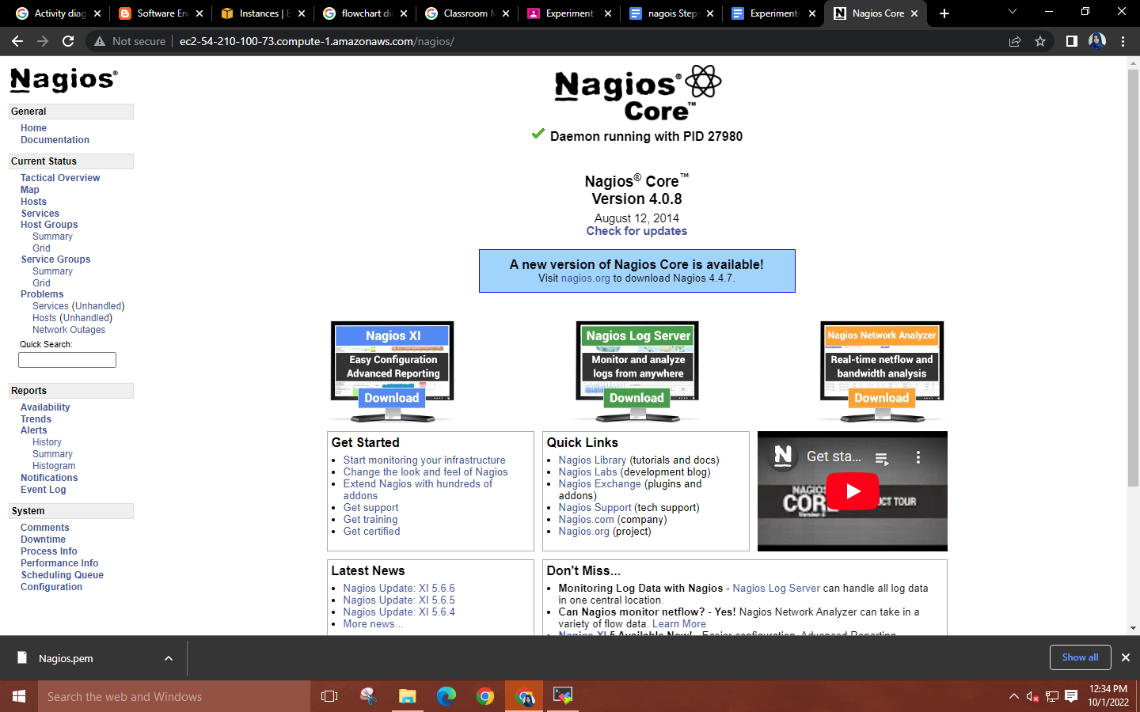

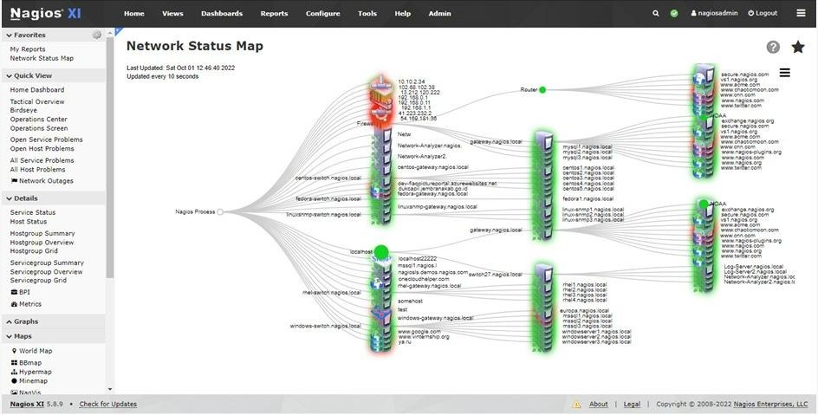

**Nagios Services:**

* Network Monitoring
* Server Monitoring
* Application Monitoring
* OS Monitoring
* Host resources Monitoring (like processor load, system log, and disk usage)
* Remote monitoring using SSL and SSH encrypted tunnels

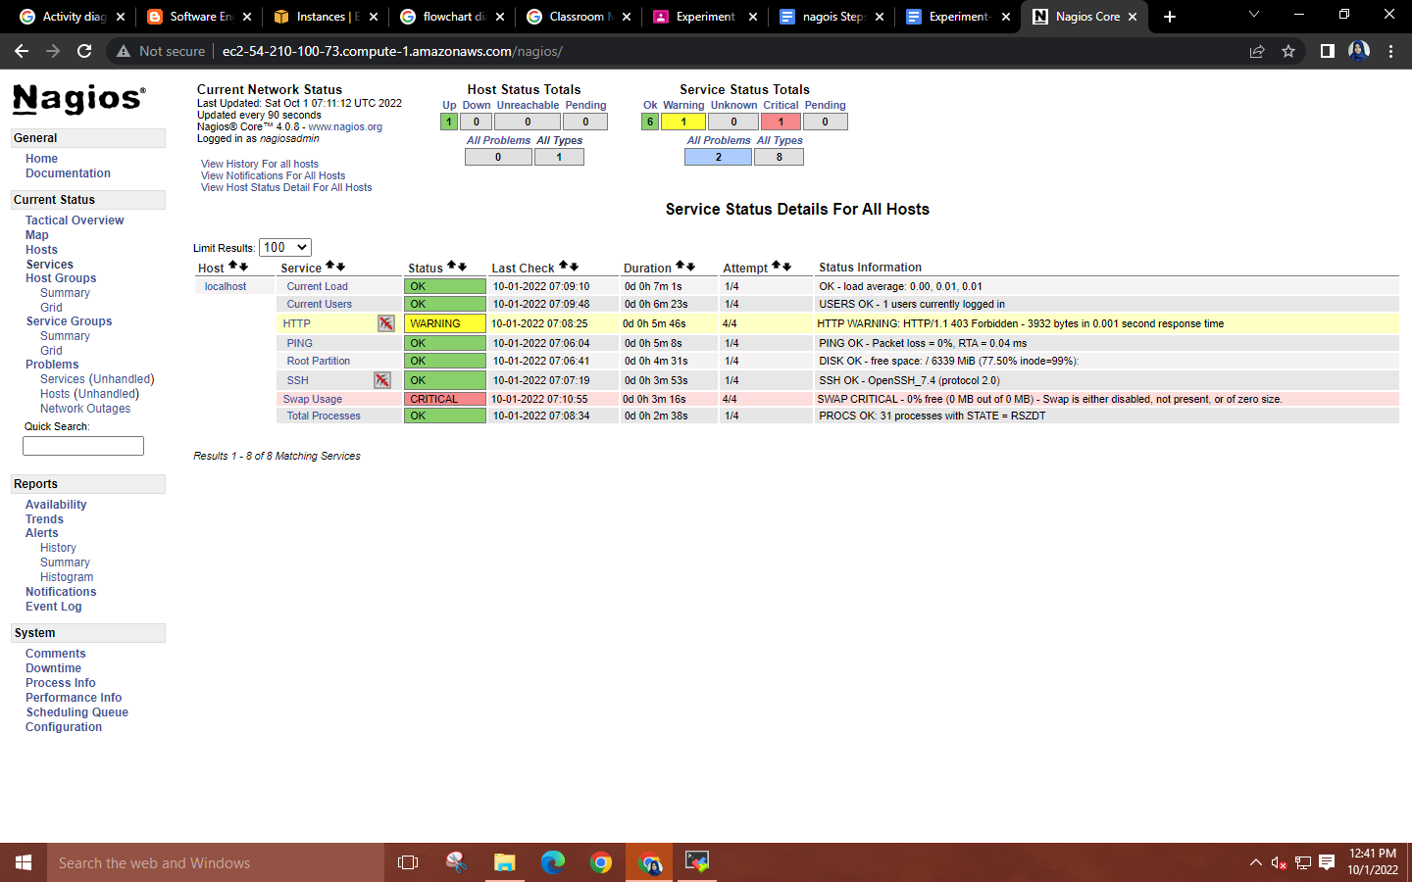

**Terminate the resource**

